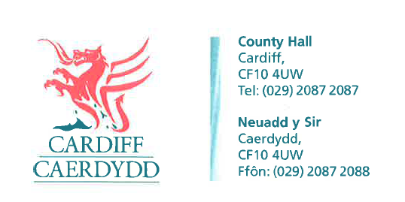
FOI Response Document
FOI18163
Thank you for your request under the Freedom of Information Act 2000 about School Places received on 21/07/2022.
Request
How many applicants got turned away from Whitchurch high school this year who applied and how many children out of catchment got a place .
We have considered your request and enclose the following information:
Response/Exemptions
207 refusals were made in Round 1
60 non-catchment were offered
If you have any queries or concerns, please do not hesitate to contact us.
Please remember to quote the reference number above in any future communications.

